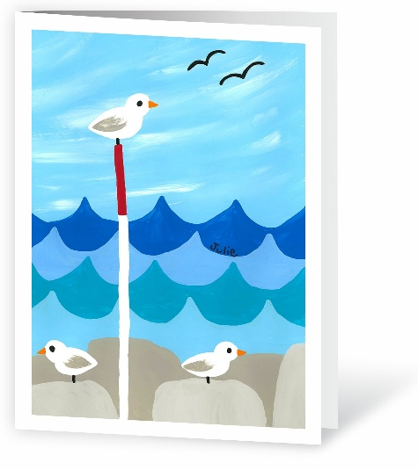


Seagull Seascape
S-014

Art Cards by Kids is an exciting fundraising opportunity for elementary schools across North America. This high-profit artwork fundraiser brings creativity into the classroom in a fun, educational, and rewarding way for students, families, and teachers alike.
We created these step-by-step instructions and videos to help teachers in the classroom guide students in creating amazing artwork for the fundraiser. Videos can easily be projected or displayed in the classroom for students to watch with guidance from their teacher. Please make sure your school has registered already and you have received our specially sized custom art sheets from the coordinator at your school before starting. Happy artistry!

www.artcardsbykids.com

Description:
Create a bright and cheerful ocean scene with rolling blue waves, rocky shores, and cute seagulls perched by the water. This fun, step-by-step painting is perfect for kids!

Materials Needed:
- Acrylic paint in white, dark blue, medium blue, light blue, red, orange, grey, and black
- Large, medium, and small round brushes
- Black permanent marker
- Paint palette
- Paper towel
- Water

Difficulty Level: Grade 3-5
See the corresponding step-by-step video to these instructions on our website under the same title.
S-014 Seagull Seascape Art Project Instructions:

- Prepare Your Art Sheet Paper
  - Place your Art Cards by Kids Art Sheet on the table vertically. Make sure the vertical arrows on the left side are pointing upwards.
  - Gather the necessary supplies as listed.
- Write your name
  - At the top, write your name, teacher's name, age, and grade in big, bold letters using a marker or pen—no pencil!
- Paint the Sky
  - With the large brush, use light blue and white paint to make big brush strokes across the top half of the page. Start with a blue base, then add white strokes and gently blend them in.
  - Allow to dry before moving on to the next step.
- Paint the First Waves
  - With the medium brush and dark blue paint, paint the first row of waves so they slightly overlap the sky. Paint five scalloped waves across the page, about two inches thick, with each wave having a point at the top and a dip in the middle.
  - Allow to dry before moving on to the next step.
- Paint the Second Waves
  - Mix dark blue and white paint to make light blue. Using the same brush, paint a second row of waves directly below the first row. Offset the waves from the first row so each point lines up under a dip from the row above.
  - Allow to dry before moving on to the next step.
- Paint the Third Waves
  - With medium blue paint and the same brush, paint a third row of waves below the second row. Line up the points and dips with the first row of waves.
  - Allow to dry before moving on to the next step.
- Paint the Fourth Waves
  - With light blue paint and the same brush, paint a fourth row of waves below the third row. Line up the points and dips with the second row.
  - Leave about 2 inches of space at the bottom of the page for the next step.
  - Allow to dry before moving on to the next step.
- Paint the Rocks
  - With grey paint and the medium brush, paint large squares and rectangles across the bottom of the page. Let them overlap the lowest waves and reach the bottom black border. Round the edges to make them look like rocks.
  - Allow to dry before moving on to the next step.
- Paint More Rocks
  - Mix grey and white to make light grey. Using the same brush, paint a second layer of rocks below the darker rocks.
  - Make different rock shapes and fill the space down to the bottom black border.
  - Allow to dry before moving on to the next step.
- Paint a Pole
  - With white paint and the small brush, paint a straight, thin line from the bottom of the page (slightly left of center) up to the top of the waves.
  - Allow to dry before moving on to the next step.
- Continue the Pole
  - With red paint and the same small brush, continue the pole halfway up into the sky.
  - Allow to dry before moving on to the next step.
- Paint the Seagulls
  - With white paint and the small brush, above the pole, paint a sideways teardrop shape with a semicircle on the top right side and fill in with paint.
  - Repeat this shape two more times just above the rocks, one on each side of the pole.
  - Allow to dry before moving on to the next step.
- Paint the Wings
  - With grey paint and the small brush, paint small wings on each seagull. Start with a point at the back of the teardrop and make the wing wider toward the center of the body.
  - Gently blend the widest part of the wing into the white body.
  - Allow to dry before moving on to the next step.
- Paint the Beaks
  - With orange paint and the small brush, paint small horizontal triangle beaks coming out from the left or right center edge of each seagull’s head.
  - Allow to dry before moving on to the next step.
- Paint Details
  - With black paint and the small brush, paint a small vertical line under each seagull for the legs.
  - Paint small dots on each seagull’s head for the eyes.
  - Paint two wide “m” shapes in the top right area of the sky to look like flying birds.
  - Allow to dry before moving on to the next step.
- Sign Your Name
  - With the black permanent marker, sign your name along the top of the second set of waves.
  - Don’t sign your name too close to the black border, or it might get cut off!!

Complete!

